

**School of Computing and Information Technology**

**Department of Computer Science & Engineering**

# B.TECH– MINOR PROJECT REPORT

*A Project Report*

*on*

# Handwritten Character Recognition

*carried out as part of the course****:*** ***CS3270*** *Submitted by*

## *Name of student*

## *Chhavi Deshlahra*

## *199301135*

&

## *Sneha Jha*

## *199301184*

## *VI-CSE*

*in partial fulfilment for the award of the degree*

*of*

## BACHELOR OF TECHNOLOGY

In

Computer Science and Engineering



## CERTIFICATE

This is to certify that the project entitled " ***Handwritten Character Recognition using CNN***" is a bona fide work carried out as part of the course ***Minor Project : CS3270***, under my guidance by ***Chhavi Deshlahra and Sneha Jha***, student of Bachelor

Of Technology (B.Tech.) in Computer Science and Engineering (CSE) at the Department of Computer

Science & Engineering , Manipal University Jaipur, during the academic semester *VI of year 2021-22.*

Place: Manipal University Jaipur

Date: 10/05/22 Signature of the Instructor (s)

## DECLARATION

I hereby declare that the project entitled **“*Handwritten Character Recognition using CNN***” submitted as part of the partial course requirements for the course Minor project (***CS3270)*** for the award of the degree of Bachelor of Technology in Computer Science and Engineering at Manipal University Jaipur in the semester during academic year 2021-22, has been carried out by me. I declare that the project has not formed the basis for the award of any degree, associate ship, fellowship, or any other similar titles elsewhere.

Further, I declare that I will not share, re-submit, or publish the code, idea, framework and/or any publication that may arise out of this work for academic or profit purposes without obtaining the prior written consent of the Course Faculty Mentor and Course Instructor.

Signature of the Student:

Place: Manipal University Jaipur

Date: 10/05/22

Table of Contents

Abstract 4

Introduction 4

Motivation 4

Challenges faced in Handwriting Recognition: 4

Uses Of Handwritten character recognition: 4

Literature Review: 6

Methodology and Framework 7

System Architecture 7

Algorithms, Techniques 7

Detailed Design Methodologies 8

Work Done 9

Conclusion 9

Future Plans 9

References 10

Abstract

Using a multilayer Feed Forward neural network, an attempt is made to recognise handwritten characters for English alphabets. The neural network is trained using the EMNIST dataset, which contains English alphabets and numbers. The EMNIST balanced dataset has 131,600-character pictures divided into 47 classes. The pixel values are normalised to obtain the feature extraction technique. The intensity of each pixel in the image is represented by pixel values that vary from 0 to 255, and they are normalised to represent values between 0 and 1. The EMNIST dataset is trained using a convolutional neural network as a classifier. The work is expanded by adding new datasets to the EMNIST dataset of Tamil language characters and training the model. The trained classifier provides a forecast for the supplied input image

# Introduction

Handwriting recognition has gotten a lot of interest in the study of pattern recognition and machine learning, due to its application in various fields. A handwriting recognition system is a method for a computer system to recognize letters and other symbols written by hand in natural handwriting. Offline handwriting recognition and online handwriting recognition are the two types of handwriting recognition. The nature of online handwriting data is dynamic. As a result, it is known that online handwriting recognition is dependent on pen trajectory and is expressed as a function of time. The writing is frequently recorded optically by a scanner and made accessible as a picture in offline recognition. In our project, handwritten character recognition is the device that interprets the user's handwritten characters or words into a format that the computer understands.

## Motivation

### Challenges faced in Handwriting Recognition:

1. Strokes have a lot of variation and ambiguity from person to person.
2. A person's handwriting style also varies from time to time and is inconsistent.
3. Degradation of the source document/image over time has resulted in poor quality.
4. Humans do not need to write a line of text in a straight line on white paper, yet text in printed documents sits in a straight line.
5. Character separation and recognition are difficult with cursive handwriting.
6. In contrast to printed text, where all of the text sits up straight, handwritten text might exhibit varied rotation to the right.
7. When compared to synthetic data, collecting a good labelled dataset to learn is not cheap.
8. A person's handwriting evolves during the course of his or her life. A comparison of written materials produced by the same person over a ten-year period will reveal significant differences.

### Uses Of Handwritten character recognition:

#### Healthcare and pharmaceuticals

Patient prescription digitization is a major pain point in the healthcare/pharmaceutical industry. For example, Roche is handling millions of petabytes of medical PDFs daily. Another area where handwritten text detection has a key impact is patient enrolment and form digitization. By adding handwriting recognition to their toolkit of services, hospitals/pharmaceuticals can significantly improve user experience

#### Banking

People write cheques on a regular basis and cheques still play a major role in most non-cash transactions. In many developing countries, the present cheque processing procedure requires a bank employee to read and manually enter the information present on a cheque and also verify the entries like signature and date. As a large number of cheques have to be processed every day in a bank a handwriting text recognition system can save costs and hours of human work

# Literature Review:

1. In 1959, Grimsdale made a major endeavour in the field of character recognition research. In the early 1960s, a method known as the analysis-by-synthesis method, proposed by Eden in 1968, was at the heart of a lot of research. Eden's work was significant because he formally established that all handwritten characters are generated by a finite number of schematic features, a point that had previously been implied. This concept was then applied to all syntactic (structural) character recognition algorithms.[1]
2. K. Gaurav, Bhatia P. K. [2] Et al, this paper deals with the various pre-processing techniques involved in the character recognition with different kind of images ranges from a simple handwritten form-based documents and documents containing coloured and complex background and varied intensities. In this, different pre-processing techniques like skew detection and correction, image enhancement techniques of contrast stretching, binarization, noise removal techniques, normalization and segmentation, morphological processing techniques are discussed. It was concluded that using a single technique for pre-processing, we can’t completely process the image. However, even after applying all the said techniques might not possible to achieve the full accuracy in a pre-processing system.
3. Salvador España-Boquera et al [3], in this paper hybrid Hidden Markov Model (HMM) model is proposed for recognizing unconstrained offline handwritten texts. In this, the structural part of the optical model has been modelled with Markov chains, and a Multilayer Perceptron is used to estimate the emission probabilities. In this paper, different techniques are applied to remove slope and slant from handwritten text and to normalize the size of text images with supervised learning methods. The key features of this recognition system were to develop a system having high accuracy in pre-processing and recognition, which are both based on ANNs.
4. In [4], a modified quadratic classifier-based scheme to recognize the offline handwritten numerals of six popular Indian scripts is proposed. Multilayer perceptron has been used for recognizing Handwritten English characters. The features are extracted from Boundary tracing and their Fourier Descriptors. The character is identified by analysing its shape and comparing its features that distinguish each character. Also, an analysis has been carried out to determine the number of hidden layer nodes to achieve high performance of the back propagation network. A recognition accuracy of 94% has been reported for Handwritten English characters with less training time. In, diagonal feature extraction has been proposed for offline character recognition. It is based on ANN model.
5. In [5]a method to construct a handwritten Tamil character by executing a sequence of strokes is proposed. A structure or shape-based representation of a stroke was used in which a stroke was represented as a string of shape features. Using this string representation, an unknown stroke was identified by comparing it with a database of strokes using a flexible string-matching procedure. A full character was recognized by identifying all the component strokes
6. In this paper, a cursive English handwritten character recognition using the deep neural network called Directed Acyclic Graph Convolutional Neural Network (DAG-CNN) is proposed.[6]
7. In this study, hand written characters will be analysed and character recognition is reviewed by utilizing, initially, DNN and later on CNN techniques.[7]
8. Toru [8] addresses the problem of reinforcing the ability of the k-NN classification of handwritten characters via distortiontolerant template matching techniques with a limited quantity of data. Three kinds of matching techniques, namely, Conventional Simple Correlation, the Tangent Distance and the Global Affine Transformation (GAT) correlation are compared. The k-NN classification method consumes a lot of time. Therefore, to reduce the computational cost of matching in k-NN classification, the GAT correlation method was accelerated by reformulating its computational model and adopting efficient lookup tables. Recognition experiments performed on the IPTP CDROM1B handwritten numerical database show that the matching techniques achieved recognition rates of 97% to 98% .The computation time ratios of the tangent distance and the accelerated GAT correlation to the simple correlation were 26.3 and 36.5 to 1.0 respectively for each technique.
9. Nasien [9] proposed a recognition model for English handwritten character recognition which includes upper and lower cases and also letters. Freeman chain code (FCC) was used as the representation technique of an image character. Chain code representation gives the boundary of a character image in which the codes represent the direction of the location of the next pixel. An FCC method that uses 8-neighbourhood that starts from direction labelled as 1 to 8 is used. Randomized algorithm was used to generate the FCC which builds the features vector.The criteria of features to input the classification is the chain code that converted to 64 features. Support vector machine (SVM) was chosen for the classification step. NIST Databases are used as the data in the experiment. By applying the proposed model, a relatively high accuracy for the problem of English handwritten recognition was reached.
10. Olarik [10] used the local gradient feature descriptors, namely the scale invariant features transform key point descriptor and the histogram of oriented gradients, for handwritten character recognition. The local gradient feature descriptors are used to extract feature vectors from the handwritten images, which were then presented to a machine learning algorithm for the actual classification. As classifiers, the k-nearest neighbour and the support vector machine algorithms were used. The feature descriptors and classifiers had been evaluated on three different language scripts, namely Thai, Bangla and Latin, consisting of both handwritten characters and digits. The results showed that the local gradient feature descriptors significantly out-perform directly using pixel intensities from the images. When the proposed feature descriptors are combined with the support vector machine, very high accuracies were obtained on the Thai handwritten datasets (character and digit), the Latin handwritten datasets (character and digit), and the Bangla handwritten digit dataset.

# Methodology and Framework

## System Architecture

### Algorithms, Techniques

A CNN is a special type of artificial neural network, which consists of one input and one output layer with multiple hidden layers. The hidden layers are convolutional layers, pooling layers, and fully connected layers [14]. The network consists of repetitive convolutional and pooling layers. Finally, it ends with one or more fully connected layers.

#### Convolutional Layer

A convolutional layer applies sliding filters vertically and horizontally through the input image. This layer learns the features of all the regions of input image while scanning. It computes a scalar product of values of the filter with the values of image regions and adds a bias for each region. A Rectified Linear Unit applies element wise activation function, viz., max (0, x), Tanh, Sigmoid: 1/ (1 + e−x) to the output of this layer for thresholding.

#### Pooling Layer

Pooling layer is generally used after one or more convolutional layers to shrink the volume of the data to make the network computationally faster. It restricts the networks from overfitting as well as provides the network into translation invariance. Max pooling and average pooling are generally used to implement pooling. It applies sliding filters vertically and horizontally through the input image to get max value or average value for each region of the input data

#### Fully Connected Layer

After all the convolutional and pooling steps, the networks generally use fully connected layers with separate neurons for each pixel like a standard neural network. The last fully connected layer contains n numbers of neurons, where n is the number of predicted classes. For digit classification problem, it should be 10 neurons for 10 classes (digit 0–9) and for English character classification problem, it should be 26 neurons for 26 classes (character a to z)

### Detailed Design Methodalogies

### After Completion of the Deep Learning Specialization course on coursera, we’ll start with the implementation of the course, which will be done the using the below order:

### ● An attempt is made to recognize handwritten characters for English alphabets using a multilayer Feed Forward neural network.

### ○ EMNIST dataset which consists of English alphabets and numbers are made use of to train the neural network. EMNIST's balanced dataset consists of 131,600 images of characters and 47 classes .

### ● The feature extraction technique will be obtained by normalizing the pixel values. Pixel values will range from 0 to 255 which represents the intensity of each pixel in the image and they are normalized to represent values between 0 and 1.

### ● Convolutional neural network is used as a classifier which will train the EMNIST dataset.

### ● The work will be extended by adding some more dataset to the EMNIST dataset of characters from Tamil language and training the model.

### ● The prediction for the given input image will be obtained from the trained classifier

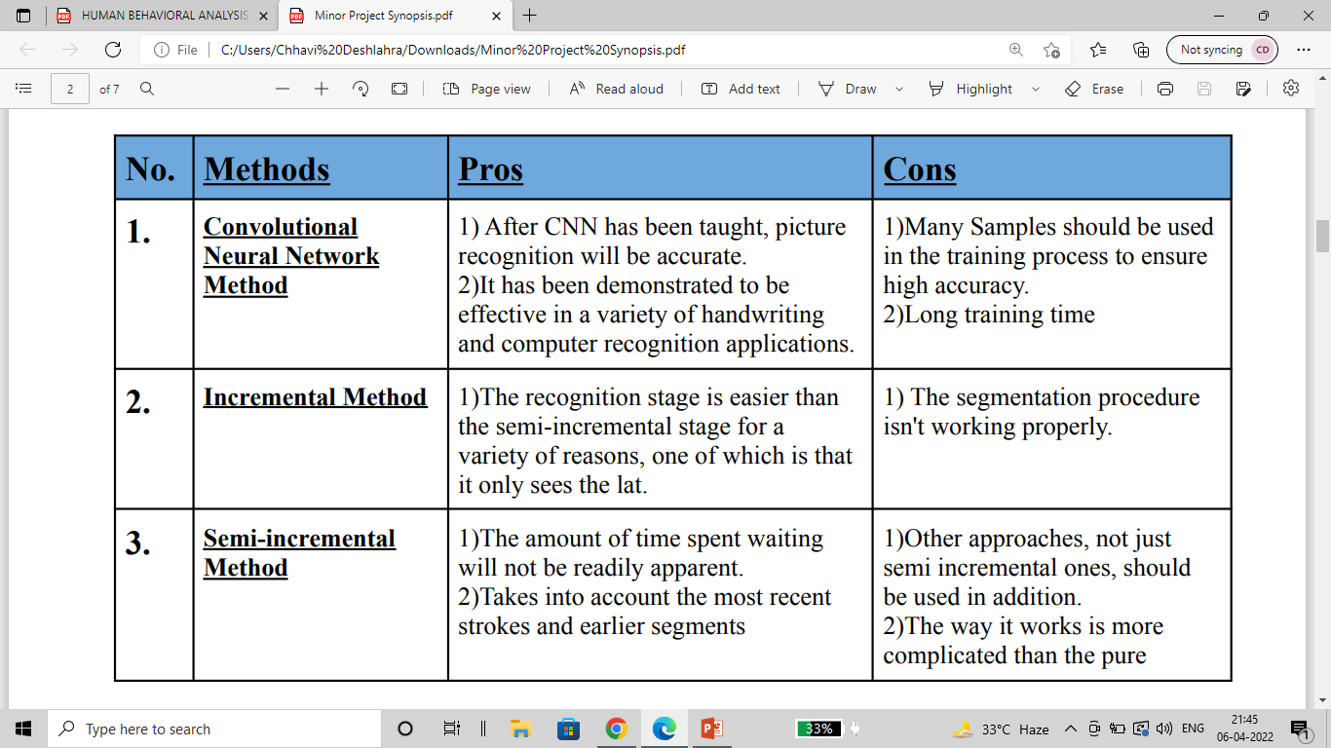

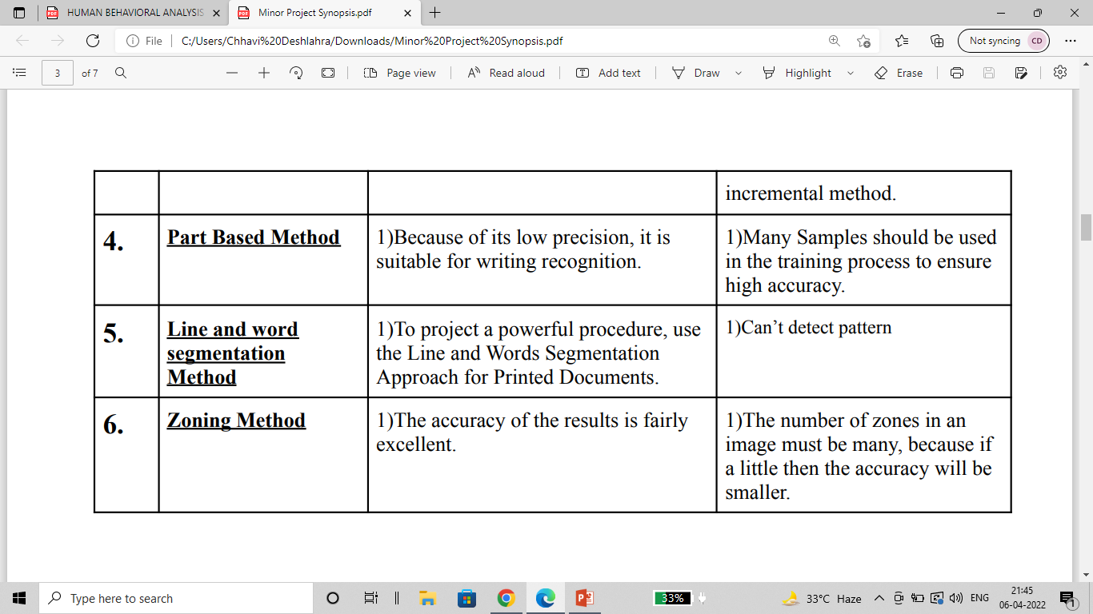

# Work Done

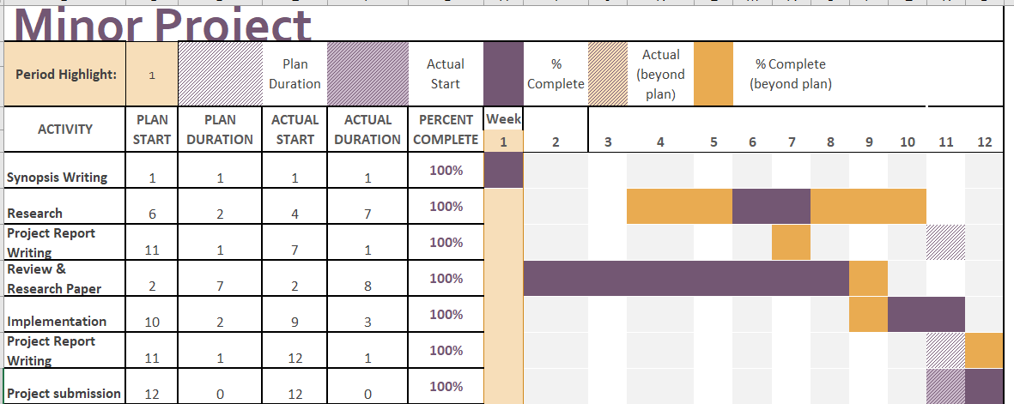

Individual Contribution::

Chhavi Deshlahra: Research, Writing ML model, Writing Review and Research papers.

Sneha Jha: Research, Writing ML model, Writing Review and Research papers.

# OUTPUTS

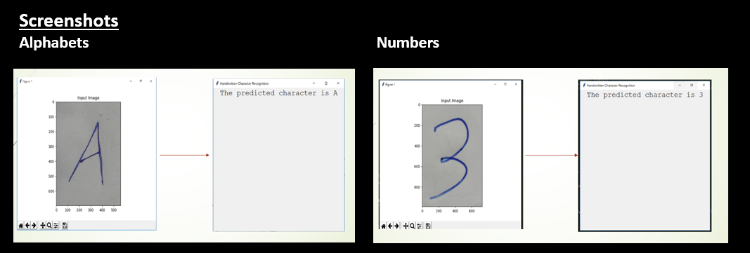

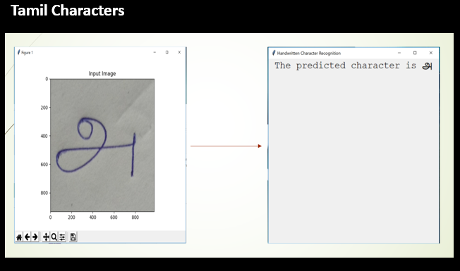

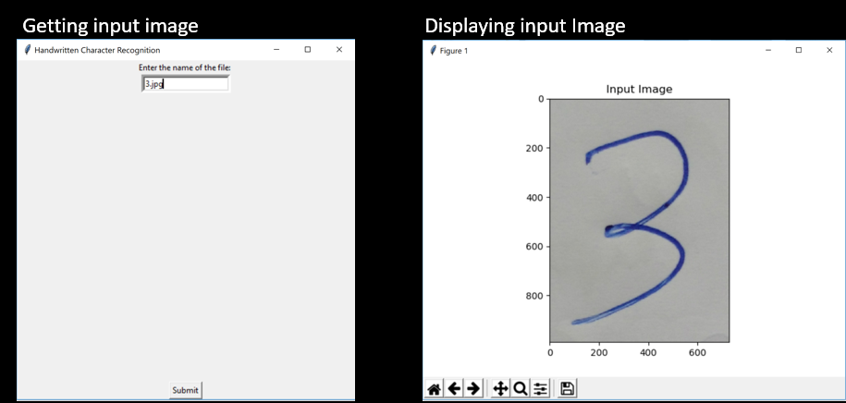

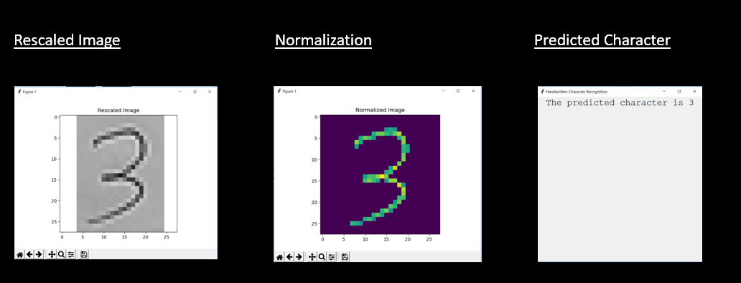

# Conclusion

1. An attempt is made to recognize handwritten characters for English alphabets using a multilayer Feed Forward neural network.
   1. EMNIST dataset which consists of English alphabets and numbers are made use of to train the neural network. EMNIST's balanced dataset consists of 131,600 images of characters and 47 classes .
2. The feature extraction technique will be obtained by normalizing the pixel values. Pixel values will range from 0 to 255 which represents the intensity of each pixel in the image and they are normalized to represent values between 0 and 1.
   1. Convolutional neural network is used as a classifier which will train the EMNIST dataset.

# Future Plans

1. The work will be extended by adding some more dataset to the EMNIST dataset of characters from Tamil language and training the model.
2. The prediction for the given input image will be obtained from the trained classifier.